TC-DVA-007
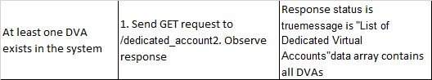
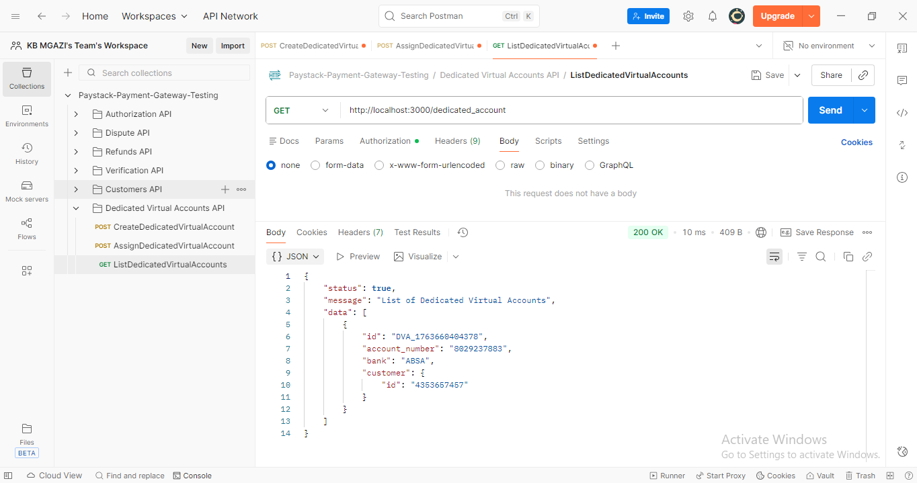
Response:
{
"status": true,
"message": "List of Dedicated Virtual Accounts",
"data": [
{
"id": "DVA_1763660404378",
"account_number": "8029237883",
"bank": "ABSA",
"customer": {
"id": "4353657457"
}
}
]
}

